9th B1+
Gold Experience B1+ Second edition Student´s book. Ed. Pearson
Gold Experience B1+ Second edition Workbook. Ed. Pearson
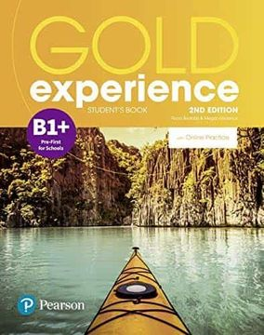
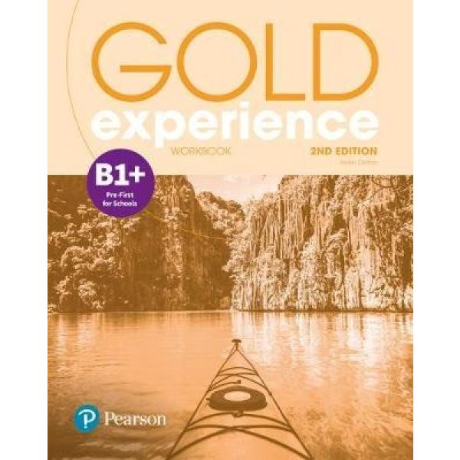
- Acevedo Florencia
- Acuña Roman *
- Aguzzi Mauricio
- Berrutti Juana
- Calviño Bernardo
- García Alegría
- Gil Ana Clara
- Guillén German
- Heuer, Ignacio
- Kuster, Janos *
- López Elias
- Luca Joaquín
- Lucero Janna
- Redin Facundo
- Servian Martina
- Verderosa Valentina
- Zamit Luzmila

